**PIZZA SALES SQL QUERRY**

1. **KPIs**
2. **Total Revenue:**

SELECT round(SUM(total_price),2) as Total_revenue from pizza_sales

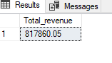

1. **AVG order value**

select sum(Total_price) / count(distinct order_id) as AVG_order_value from pizza_sales

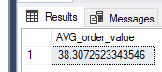

1. **Total pizza sold**

select sum(quantity)as Total_pizza_sold from pizza_sales

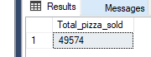

1. **Total order placed**

select count(distinct order_id) as Total_order from pizza_sales

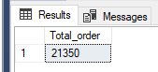

1. **Average pizza per order**

select cast(sum(quantity)as decimal (10,2))/cast(count (distinct order_id)as decimal(10,2))as avg_pizza_per_order from pizza_sales

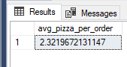

1. **Daily trends for total order**

SELECT DATENAME(DW, order_date) AS order_day, COUNT(DISTINCT order_id) AS total_orders

FROM pizza_sales

GROUP BY DATENAME(DW, order_date)

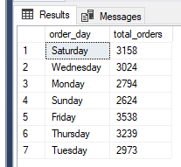

1. **Monthly trends for orders**

select DATENAME(MONTH, order_date) as Month_Name, COUNT(DISTINCT order_id) as Total_Orders from pizza_sales

GROUP BY DATENAME(MONTH, order_date)

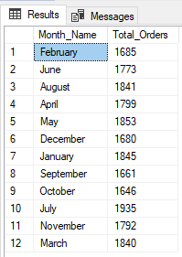

1. **% of Sales by Pizza Category**

SELECT pizza_category, CAST(SUM(total_price) AS DECIMAL(10,2)) as total_revenue,CAST(SUM(total_price) * 100 / (SELECT SUM(total_price) from pizza_sales) AS DECIMAL(10,2)) AS PCT

FROM pizza_sales

GROUP BY pizza_category

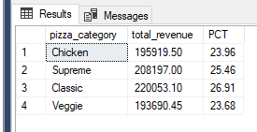

1. **% of Sales by Pizza Size**

SELECT pizza_size, CAST(SUM(total_price) AS DECIMAL(10,2)) as total_revenue,

CAST(SUM(total_price) * 100 / (SELECT SUM(total_price) from pizza_sales) AS DECIMAL(10,2)) AS Percetage_sales

FROM pizza_sales

GROUP BY pizza_size

ORDER BY pizza_size

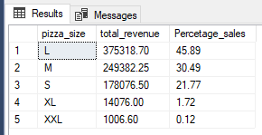

**F. F. Total Pizzas Sold by Pizza Category**

SELECT pizza_category, SUM(quantity) as Total_Quantity_Sold

FROM pizza_sales

WHERE MONTH(order_date) = 2

GROUP BY pizza_category

ORDER BY Total_Quantity_Sold DESC

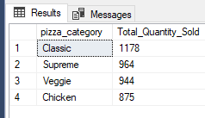

1. **Top 5 pizzas by Revenue**

SELECT Top 5 pizza_name, SUM(total_price) AS Total_Revenue

FROM pizza_sales

GROUP BY pizza_name

ORDER BY Total_Revenue desc

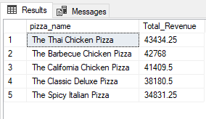

**H. Bottom 5 Pizzas by Revenue**

SELECT Top 5 pizza_name, SUM(total_price) AS Total_Revenue FROM pizza_sales GROUP BY pizza_name ORDER BY Total_Revenue ASC

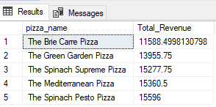

**I. Top 5 Pizzas by Quantity**

SELECT Top 5 pizza_name, SUM(quantity) AS Total_Pizza_Sold

FROM pizza_sales

GROUP BY pizza_name

ORDER BY Total_Pizza_Sold DESC

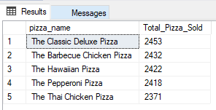

**J. Bottom 5 Pizzas by Quantity**

SELECT TOP 5 pizza_name, SUM(quantity) AS Total_Pizza_Sold

FROM pizza_sales

GROUP BY pizza_name

ORDER BY Total_Pizza_Sold ASC

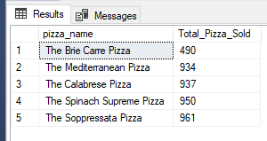

**K. Top 5 Pizzas by Total Orders**

SELECT Top 5 pizza_name, COUNT(DISTINCT order_id) AS Total_Orders

FROM pizza_sales

GROUP BY pizza_name

ORDER BY Total_Orders DESC

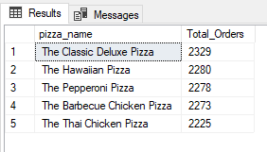

**L. Bottom 5 Pizzas by Total Orders**

SELECT Top 5 pizza_name, COUNT(DISTINCT order_id) AS Total_Orders

FROM pizza_sales

GROUP BY pizza_name

ORDER BY Total_Orders ASC

